**YOUR DOG’S HOME AWAY FROM HOME.**



**Happy Dogs**



October 28, 2023

HAPPY DOGS

happydogs@gmail.com

**GROUP MEMBERS**

1. Kibet Jepchumba Mercy HSB214-0109/2022 MB
2. Millicent Akinyi Dinda HSB 212-0048/2022 BMB
3. Ruth Atieno Otieno HSB212-0432/2022 BMB



Welcome to Happy Dogs, your trusted partner for professional and quality dog sitting service. At happy Dogs we understand that your puppies and dogs deserve the very best care and attention, whether it’s for hours or days. With years of experience and passion for the fur family and a commitment to the wellbeing, we offer a range of services that makes us useful for pet owners like you.

We also offer in-home dog sitting for periods of time from one day to two weeks. In our place or your home, a trusted and proven sitter will:

* Provide food and water according to your instruction.
* Walk or exercise the dog for 45 minutes up to three times daily.
* Administer needed medication to your dog. 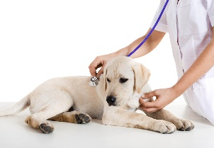
* Nurture and provide loving attention for your dog in your absence.
* 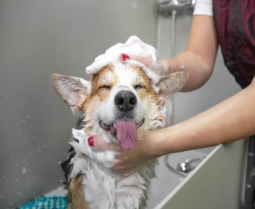Stay in your home overnight with your dog.
* Pamper your dog with our grooming and spa services
* Basic obedience training to help your dog become well mannered.

Our pricing depends on the number of dogs, duration of the sit, and services required. Here are some samples package price

|  |  |  |
| --- | --- | --- |
| **Package** | **Price per Day** | **Price per Night** |
| 1. 1 -3 | Kshs 500 | Kshs 600 |
| 1. 3-5 | Kshs 1300 | Kshs 1400 |
| 1. 6-∞ | Kshs 2500 | Kshs 2600 |
| 1. 1 Dog Evening Walk | @Kshs 300 | - |
| 1. 1 Dog Behavior training | @kshs 400 | - |

Stop missing out on those weekends at the lake with friends. Stop turning down opportunities at work because they require overnight travel.

Contact us at [happydog@gmail.com](mailto:happydog@gmail.com) or call +254789878787.